



**BACHELOR IN INFORMATION TECHNOLOGY**

Submitted by: Submitted to:

ISHWOR KHATIWADA Lincoln University College

Year/ Semester: 1stSemester/1stYear

LCID: LC00017000772

**Date: 03-07-2020**

Q.n.1.

What is K-map? Why it is used? Explain k-map with example.

K-map abbreviates for Karnaugh Map which was introduced in 1953 by Maurice Karnaugh. It is the graphical representation of any given expression which is a simplification of Boolean algebra. We can construct k-map using 2, 3, 4 variables.

The following are the main uses of k-map:

1. K-map is used to minimize the number of logic gates that you use to implement any digital circuit.
2. Its simplification technique is easier and simple also chance of less error in designing it.
3. The minimization will reduce cost, efficiency and power consumption.
4. K-map is tabular like representation however it gives more information than a truth table .

For Example:

SOP FORM of K-map of 3 variables:

Z= ∑A,B,C(1,3,6,7)

Solution:

A BC 00 01 11 10

|  |  |  |  |
| --- | --- | --- | --- |
| 0    0 | 1  1 | 1  3 | 0  2 |
| 0  4 | 0  5 | 1  7 | 1  6 |

2. What is an expansion slot? Explain its types?

The expansion card is a circuit board that improves the functions of

a system unit element and provides a direct link to a peripheral unit of computer systems.

IT provides additional features like video, sound, graphics, wireless Ethernet, as well as external memory to a computer system.

The following are different types of expansion slot with their features:

* PCI – Network card, SCSI, Sound card, Video card.
* PCI Express – Video card.
* AGP – Video card.

PCI: (Peripheral Component Interconnect) is a hardware used to insert internal components to a computer system. It is    a quick way to upgrade your computer, because you can add a better video card, faster wired or wireless communications, or add new connectors like USB ports.

PCIe :(Peripheral Interconnect Express) is a conventional interface for connecting high-speed computer elements. Almost every desktop PC motherboard has a number of PCIe slots which can  be used to add GPUs (like video cards and graphics cards), RAID cards, Wi-Fi cards, or SSD (solid-state) add-on cards.

AGP:(Accelerated Graphics Port) is a type of expansion slot made especially for graphics cards. It is a point-to -point channel used for high-speed video outcome. This port is used to connect graphics cards to the motherboard. The main objective of the AGP is to improve the performance of Computer animations for high resolution content.

3. What is chipset? Explain the Northbridge and Southbridge?

Chipset is a collection of integrated circuits intended to function together as a module, in particular to do a specified task inside computer hardware. It monitors the transfer of data and instructions between CPU, a microprocessor and an external computer. The chipset controls external buses, memory cache, and other peripherals. Examples of chipsets are AMD, Intel, NVidia, etc. A chipset has two sections Southbridge and Northbridge with specific sets of functions that communicate between the CPU and external devices.

Northbridge:

The Northbridge connects the CPU to very high-speed devices, such as RAM and graphics controllers.  It is used for connecting CPU to the memory, cache, PCI express bus and so on. The Northbridge is a chip in the motherboard chipset that allows directly access to the CPU. The Northbridgeisalso known as Memory Controller Hub, and usually pairs with a Southbridge.

Southbridge:

The Southbridge architecture is the chip section that is responsible for all of the computers I/O functions, such as USB, audio, serial and the system BIOS. It is not directly connected to the CPU, and is also known as the input/output controller hub.Southbridge basically is an Intel chipset. It manages communications between the CPU and other parts of the motherboard as well as constitutes the core logic chipset of the PC motherboard.

4. What is BIOS? Explain its functions?

BIOS (basic input-output system)is a low-level software used by a personal computer that starts when you turn device on. It is pre-installed on Widow based computer systems .This also controls data transfer from the operating system of the device and the related components, such as the hard drive, monitor, mouse and printer. The Bios chip is placed on your device motherboard. BIOS is responsible for loading the basic computer hardware startup test and booting the operating system. The BIOS contains a variety of instructions for hardware loading.

The main functions of BIOS are:

1. Power on Self-Test (POST): The first and important task of BIOS is to guarantee that the hardware of the device is running correctly and that there is no hardware problem. It is achieved with the Power on Self Check (POST). If the POST check fails, the machine produces various forms of beeps to signify the error type. If the POST test is passed, the boot will starts after then.
2. Booting up:

Upon complete completion of the POST, the BIOS finds and classify the operating devices model and Locate the operating system. The BIOS will then pass the control to the operating system,which is named booting.

1. Bios drivers:

BIOS drivers are a collection of programs that are stored in non-volatile erasable memory chips and are low-level drivers that give the computer basic functionality, Control the hardware of your computer. It gives basic information about the hardware of the computer.

1. Setup of BIOS

It is a configuration program that allows us to configure hardware settings that include system settings such as computer passwords, time, boot priority, etc.

And this is the date. BIOS setup is also referred to as the CMOS setup

Q.N.5. Explain the different types of logic gates with its logic diagram and truth table.

ANS:

The logic gate is the foundation block for the digital electronics circuit. Most logical gates have two inputs and one output and are based on the Boolean algebra. There are 7 basic logic gates they are:

AND, OR, EXOR, NOT, NAND, NOR, and EXNOR.

* **AND gate**

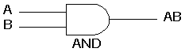 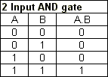

The AND gate gives a high output (1) only if all its inputs are high.  A dot (.) is used to show the AND operation i.e. A.B

* **OR gate**

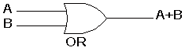 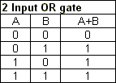

The OR gate gives a high output (1) if one or more of its inputs are high.  A plus (+) is used to show the OR operation.

* **NOT gate**

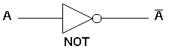 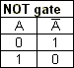

The NOT gate produces an inverted version of the input at its output.  It is also known as an inverter.

* **NAND gate**

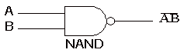 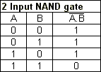

This is a NOT-AND gate which is equal to an AND gate followed by a NOT gate.  The outputs of all NAND gates are high if **any** of the inputs are low.

* **NOR gate**

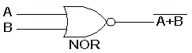 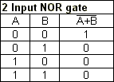

This is a NOT-OR gate which is equal to an OR gate followed by a NOT gate.  The outputs of all NOR gates are low if **any** of the inputs are high.

* **EXOR gate**

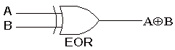 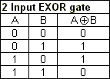

The '**Exclusive-OR**' gate is a circuit which will give a high output if **either, but not both**, of its two inputs are high.

* **EXNOR gate**

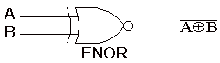 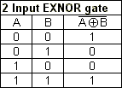

The 'Exclusive**-NOR'**gate circuit does the opposite to the EXOR gate. It will give a low output if either**,** butnotboth, of its two inputs are high.